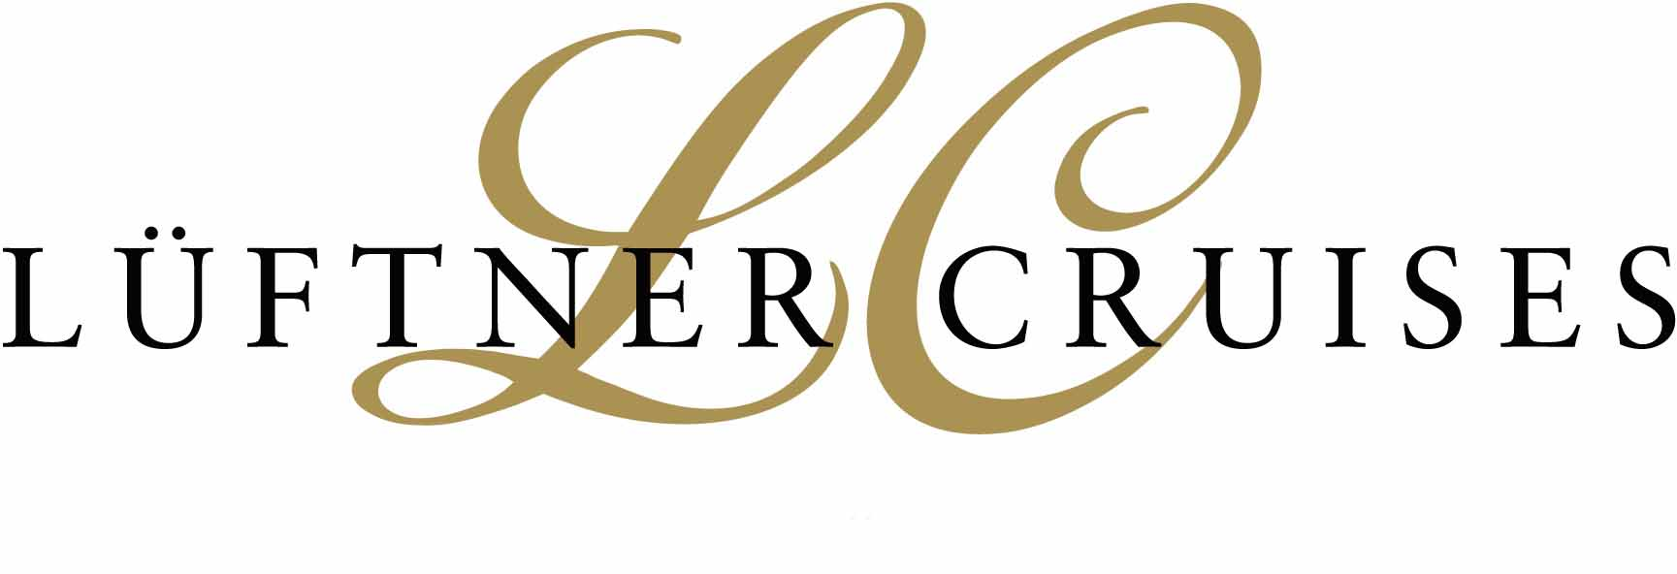
Press Release
Innsbruck, December 20th 2010

AMADEUS Brilliant: Launching our new flagship

After 10 months construction Lüftner Cruises launches its 9th AMADEUS vessel

On Saturday 18th December the AMADEUS Brilliant took to the water for the first time at the De Hoop shipyard in the Dutch town of Foxhol. The spectacular sideways launching was again the hightight of this festive ceremony.
The 110-m long newcomer is the ninth river cruiser that Lüftner Cruises has commissioned from this Dutch shipyard. “The decision to build another AMADEUS vessel was necessary in order to be able to meet the high demand for capacity in the premium segment of the market”, explains Dr. Wolfgang Lüftner, founder and CEO of Lüftner Cruises.
In April 2011 the AMADEUS Brilliant will make its debut with a 5-day maiden cruise, starting directly after its launching at the shipyard in the Dutch town of Lobith, and making its way to Strasbourg via Coblenz and Mannheim.
The ship has 76 outside cabins, 64 of which have French balconies. Great attention is being given to the customary high standards of spaciousness and design-orientated interior fittings found on our AMADEUS ships. The AMADEUS Brilliant’s range of comforts is rounded off with a fitness studio and massage salon, the AMADEUS-Club with its panoramic windows, and a lift connecting all the decks.

Press Contact:
Anna Lüftner, Director Marketing and Public Relations
Amraser See Strasse 56 – Menardi Center – A-6020 Innsbruck
Tel: +43 512 365781-17
Fax: +43 512 365781-6
Email: anna.lueftner@lueftner-cruises.com
Web: www.lueftner-cruises.com

